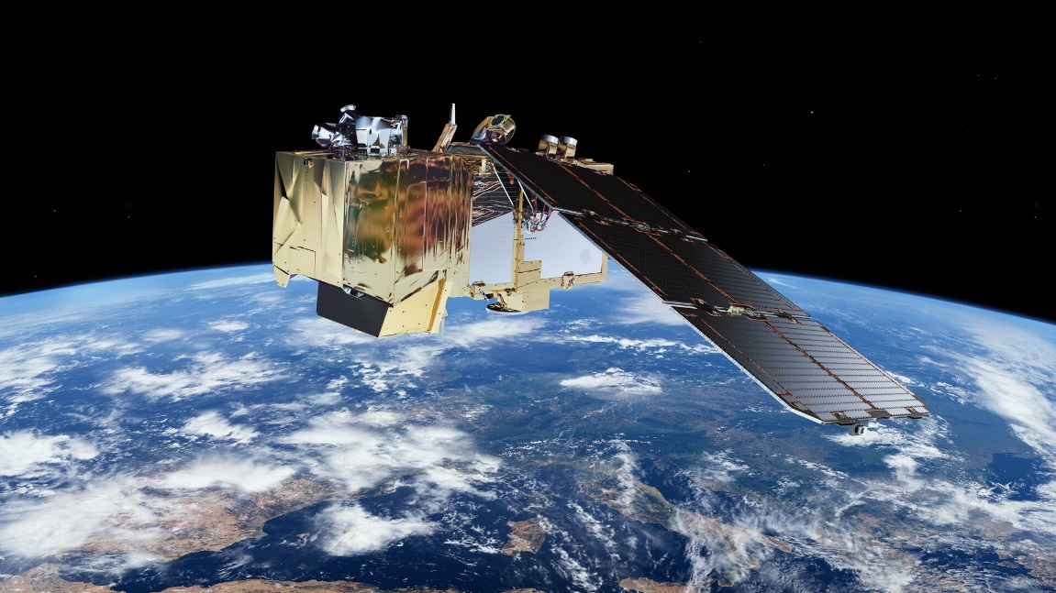

Water Quality Measurement Python Library

Documentation

# What does the library do?

The Python library is a standalone library that is able to download satellite imagery and process it to extract water quality parameters of a defined region.

About the satellites

## Sentinel 2

Sentinel-2 is a satellite mission of the European Space Agency (ESA) that captures high-resolution optical imagery of the Earth's surface. The mission operates two identical satellites, Sentinel-2A and Sentinel-2B, in a polar orbit at an altitude of 786 km.The satellite carries a multispectral imager that captures data in 13 spectral bands, including visible and near-infrared wavelengths. The data is collected at a high spatial resolution of 10-20 meters per pixel, and is suitable for a wide range of applications, including mapping of land use and land cover, monitoring of vegetation, and detection of changes in the Earth's surface.

Sentinel 3

SENTINEL-3 is an European Earth Observation satellite mission developed to support Copernicus ocean, land, atmospheric, emergency, security and cryospheric applications.

The main objective of the SENTINEL-3 mission is to measure sea surface topography, sea and land surface temperature, and ocean and land surface colour with high accuracy and reliability to support ocean forecasting systems, environmental monitoring and climate monitoring. The mission definition is driven by the need for continuity in provision of ERS, ENVISAT and SPOT vegetation data, with improvements in instrument performance and coverage.

The SENTINEL-3 mission is jointly operated by ESA and EUMETSAT to deliver operational ocean and land observation services.

Landsat 8/9

Landsat shows us Earth from space. Since the first Landsat satellite launched in 1972, the mission has collected data on the forests, farms, urban areas and freshwater of our home planet, generating the longest continuous record of its kind. Decision makers from across the globe use freely available Landsat data to better understand environmental change, manage agricultural practices, allocate scarce water resources, respond to natural disasters and more.

With the launch of Landsat 9 scheduled for mid-2021, the mission will continue its legacy of monitoring key natural and economic resources from orbit. Landsat 9, managed by NASA’s Goddard Space Flight Center in Greenbelt, Maryland, will carry two instruments: the Operational Land Imager 2 (OLI-2), which collects images of Earth’s landscapes in visible, near-infrared and shortwave infrared light, and the Thermal Infrared Sensor 2 (TIRS-2), which measures the temperature of land surfaces. Like its predecessors, Landsat 9 is a joint mission of NASA and the U.S. Geological Survey.

Water Quality Parameters

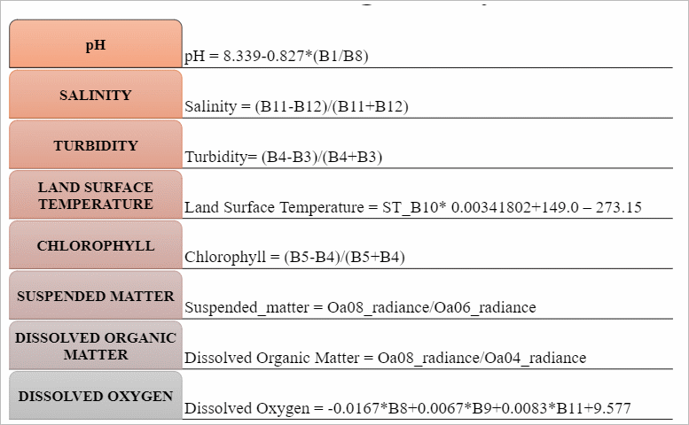

Land surface Temperature

For the measurement of land surface temperature, we use the ST_B10 (TIR 1) band that can be obtained from LANDSAT Satellites.

$$\boxed{LST=0.00341802*ST_B10+149.0-273.15°C}$$

Normalized Difference chlorophyll index (NDCI)

The Normalized Difference Chlorophyll Index (NDCI) is a vegetation index used to estimate chlorophyll content in plants, particularly in aquatic environments. The NDCI is calculated by taking the difference between two bands of the electromagnetic spectrum that are sensitive to chlorophyll absorption and dividing it by their sum. For this, we use the B5 (Vegetation Red Edge 1) and B4 (Red) bands of Sentinel-2.

$$\boxed{NDCI=\frac{B5-B4}{B5+B4}}$$

Normalized Difference Water index (NDwI)

The Normalized Difference Water Index (NDWI) is a spectral index used to identify and map water bodies in remote sensing applications. It leverages the difference in reflectance properties of water and other land features in certain bands of the electromagnetic spectrum. For this, we use the B5 (Vegetation Red Edge 1) and B3 (Green) bands of Sentinel-2.

$$\boxed{NDWI=\frac{B3-B5}{B3+B5}}$$

Normalized Difference Turbidity index (NDTI)

The Normalized Difference Turbidity Index (NDTI) is a spectral index used to estimate the turbidity or clarity of water bodies based on remote sensing data. Turbidity refers to the degree to which water loses its transparency due to suspended particles, such as sediment, algae, or other organic and inorganic matter. For this, we use the B4 (Red) and B3 (Green) bands of Sentinel-2.

$$\boxed{NDTI=\frac{B4-B3}{B4+B3}}$$

Normalized Difference salinity index (NDsI)

The Normalized Difference Salinity Index (NDSI) is an index that attempts to estimate or infer salinity levels in water bodies using remote sensing imagery. The specific formula for calculating the NDSI may vary depending on the research or study being conducted. However, a common approach is to leverage the spectral bands sensitive to salinity variations. For this, we use the B11 (SWIR 1) and B12 (SWIR 2) bands of Sentinel-2.

$$\boxed{NDSI=\frac{B11-B12}{B11+B12}}$$

pH

The pH of water bodies refers to the measurement of the acidity or alkalinity of the water. pH is a logarithmic scale that ranges from 0 to 14, with 7 being considered neutral. Values below 7 indicate acidity, while values above 7 indicate alkalinity.

The pH of water bodies is an important parameter as it affects the chemical and biological processes within the water and can have significant implications for aquatic life and ecosystem health. Extreme pH levels can be detrimental to aquatic organisms and impact water quality. For this, we use the B1 (Coastal/Aerosol) and B8 (NIR) bands of Sentinel-2.

$$\boxed{pH=8.339-0.827 * \frac{B1}{B8}}$$

Dissolved Oxygen (DO)

Dissolved oxygen (DO) refers to the amount of oxygen gas (O2) dissolved in water. It is a crucial parameter for aquatic ecosystems as it directly affects the survival and health of aquatic organisms, particularly fish and other aquatic animals.

DO enters water through various processes, such as diffusion from the atmosphere, aeration from wind and waves, and photosynthetic oxygen production by aquatic plants and algae. On the other hand, oxygen is consumed by processes like respiration of aquatic organisms, decomposition of organic matter, and chemical reactions. For this, we use the B8 (NIR), B9 (Water Vapour) and B11 (SWIR) bands of Sentinel-2.

$$\boxed{DO=9.577-0.0167*B8+0.0067*B9+0.0083*B11}$$

Suspended Matter

Suspended matter refers to solid particles or material that is suspended in water or other fluids. These particles can vary in size, composition, and origin. Suspended matter is an important parameter to monitor in aquatic systems as it influences water quality, ecosystem dynamics, and various environmental processes. For this, we use the Oa08 (Red) and Oa06 (Green) bands of Sentinel-3.

$$\boxed{SuspendedMatter=\frac{Oa08}{Oa06}}$$

Dissolved organic matter

Dissolved organic matter (DOM) refers to the fraction of organic compounds that are dissolved in water. It consists of complex mixtures of carbon-based compounds derived from the decomposition, decay, and dissolution of organic materials such as plants, animals, and microorganisms. For this, we use the Oa08 (Red) and Oa04 (Blue) bands of Sentinel-3.

$$\boxed{DOM=\frac{Oa08}{Oa04}}$$

Library Dependencies

Please make sure that the following Python libraries are installed for the functioning of the library (Install using terminal – “pip install <library_name>”).

1. numpy
2. matplotlib
3. fiona
4. rasterio
5. sentinelsat
6. landsatexplore
7. eoreader

Library Functions

Downloading Satellite Imagery

1. Sentinel-2 and Sentinel-3 imagery can be downloaded from the Copernicus Hub - <https://scihub.copernicus.eu/dhus/#/home>. Note that you will have to register and create an account to use its API services.
2. LandSat imagery can be downloaded from the USGS Earth Explorer website – <https://earthexplorer.usgs.gov/>. Note that you will have to register and create an account to use its API services.

### downloadSentinel2Products(username, password, start_date, end_date)

This function downloads Sentinel-2 imagery using the SentinelAPI for Python. The Copernicus Hub credentials are input to use the API services. The start date and end date for the imagery download can be passed to the function. The API parameters have been set to download imagery containing Hyderabad region. Note that the Sentinel-2 revisit time is around 5 days so set the start and end dates accordingly. The naming conventions for the downloaded files can be found at the given user guide link - https://sentinels.copernicus.eu/web/sentinel/user-guides/sentinel-2-msi/naming-convention

### downloadSentinel3Products(username, password, start_date, end_date)

This function downloads Sentinel-3 imagery using the SentinelAPI for Python. The Copernicus Hub credentials are input to use the API services. The start date and end date for the imagery download can be passed to the function. The API parameters have been set to download imagery containing Hyderabad region. Note that the Sentinel-3 revisit time is around 1-2 days so set the start and end dates accordingly. The naming conventions for the downloaded files can be found at the given user guide link - https://sentinels.copernicus.eu/web/sentinel/user-guides/sentinel-3-olci/naming-convention

### downloadLandSatProducts(username, password, start_date, end_date)

This function downloads Sentinel-3 imagery using the LandSat and Earth Explorer API for Python. The USGS and Earth Explorer credentials are input to use the API services. The start date and end date for the imagery download can be passed to the function. The API parameters have been set to download imagery containing Hyderabad region. Note that the LandSat revisit time is around 10-14 days so set the start and end dates accordingly. The API might throw login failed exceptions if the function is called consecutively in a short span of time. The naming conventions for the downloaded files can be found at the given user guide link - <https://www.usgs.gov/faqs/what-naming-convention-landsat-collections-level-1-scenes>

Generating TIFF Rasters

The TIFF raster files containing the necessary bands for further processing are obtained from the satellite imagery.

* generateSentinel2TIFF(product_path, resoultion = 60.)

This function generates a TIFF raster stack containing the necessary bands (['COASTAL_AEROSOL','GREEN','RED','VEGETATION_RED_EDGE_1','NIR','WATER_VAPOUR','SWIR_1','SWIR_2']) from the Sentinel-2 imagery specified by product_path. This is done using the help of EOReader Python library. The default resolution is set to 60 metres. It is advisable to limit the resolution to over 20 metres for faster processing and moderate TIFF file size.

* generateSentinel3TIFF(product_path, resoultion = 200.)

This function generates a TIFF raster stack containing the necessary bands (['BLUE','GREEN','RED']) from the Sentinel-3 imagery specified by product_path. This is done using the help of EOReader Python library. The default resolution is set to 200 metres. It is advisable to limit the resolution to over 150 metres for faster processing and moderate TIFF file size. The generated TIFF file is named “stack_sentinel2.tif”.

* generateLandSatTIFF(product_path)

This function generates a TIFF raster stack containing the necessary band (['ST_B10’]) from the LandSat imagery specified by product_path. This is done using the help of tarfile Python library. The generated TIFF file is named “stack_landsat.tif”.

CLipping of Lake REgion

To assess the water quality parameters of Osman Sagar Lake, we first clip the region containing the lake using QGIS software (<https://mapscaping.com/how-to-create-a-polygon-qgis/>). This creates a shape file with polygon geometry that contains the coordinates of the Lake in the required CRS (Coordinate Reference System) needed by the raster stack TIFF files. The shape file geometry is shown below –

* clipRegion(tif_path, aoi_path, dest_path)

This function generates a clipped version of the TIFF file specified by tif_path and the result is stored at dest_path (for example, “clip_sentinel2.tif”). The clipped TIFF file contains raster data only of the region specified by aoi_path (the shape file location).

PRocessing of clipped tiff file for water quality parameters

The 9 water quality parameters can be obtained from the clipped raster TIFF files of Sentinel-2 imagery, Sentinel-3 imagery and LandSat imagery.

* processSentinel2TIFF(tif_path)

This function takes the location of the clipped Sentinel-2 imagery TIFF file and returns 6 water quality parameter values (ndci_mean, ndwi_mean, ndsi_mean, ndti_mean, ph_mean, do_mean), along with the plots of the values corresponding to the clipped region. The function also plots the data along with the mean values.

* processSentinel3TIFF(tif_path)

This function takes the location of the clipped Sentinel-3 imagery TIFF file and returns 2 water quality parameter values (Suspended Matter mean and Dissolved Organic Matter mean), along with the plots of the values corresponding to the clipped region. The function also plots the data along with the mean values.

* processLandSatTIFF(tif_path)

This function takes the location of the clipped LandSat imagery TIFF file and returns 1 water quality parameter value (Land Surface Temperature mean), along with the plot of the values corresponding to the clipped region. The function also plots the data along with the mean value.

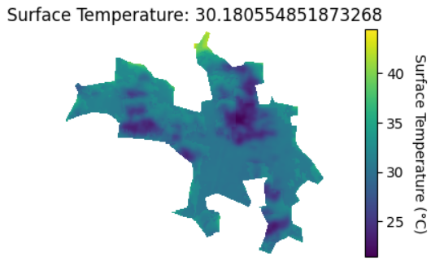

References

1. <https://sentinel.esa.int/web/sentinel/missions/sentinel-2>
2. <https://sentinels.copernicus.eu/web/sentinel/missions/sentinel-3/overview>
3. <https://www.nasa.gov/mission_pages/landsat/overview/index.html>
4. <https://omdena.com/blog/satellite-imagery-for-water-quality-monitoring/>
5. <https://docs.digitalearthafrica.org/en/latest/data_specs/Landsat_C2_ST_specs.html>
6. <https://scihub.copernicus.eu/dhus/#/home>
7. <https://earthexplorer.usgs.gov/>
8. <https://sentinels.copernicus.eu/web/sentinel/user-guides/sentinel-2-msi/naming-convention>
9. <https://sentinels.copernicus.eu/web/sentinel/user-guides/sentinel-3-olci/naming-convention>
10. <https://www.usgs.gov/faqs/what-naming-convention-landsat-collections-level-1-scenes>
11. <https://eoreader.readthedocs.io/en/v0.20.0/>
12. <https://sentinelsat.readthedocs.io/en/stable/api_overview.html>
13. <https://github.com/yannforget/landsatxplore>
14. <https://rasterio.readthedocs.io/en/stable/topics/reading.html>
15. <https://fiona.readthedocs.io/en/stable/>
16. <https://mapscaping.com/how-to-create-a-polygon-qgis/>